Long-term effects of selective logging on a production forest's succession of the Amazon

Ulrike Hiltner

2017-11-30

Ulrike Hiltner1,2,°, Achim Bräuning1, Bruno Hérault3, Andreas Huth2,4,5, Rico Fischer2

*1Institute of Geography, Friedrich-Alexander-University Erlangen-Nuremberg, Wetterkreuz 15, 91058 Erlangen, Germany*

*2Department of Ecological Modelling, Helmholtz-Centre for Environmental Research GmbH - UFZ, Permoserstr. 15, 04318 Leipzig, Germany*

*3Department ..., Centre International de Recherche en Agronomie pour le Développement - CIRAD, Av. de France .., ... Kourou, Fr. Guiana*

*4Institute of Environmental System Research, University of Osnabruck, Barbarastr. 12, 49076 Osnabruck, Germany*

*5German Centre for Integrative Biodiversity Research iDiv, University of Leipzig, Deutscher Platz 5e, 04103 Leipzig, Germany*

*°Corresponding author. Tel. +49(0)341-235-1723; E-mail:* [*ulrike.hiltner@ufz.de*](mailto:ulrike.hiltner@ufz.de)

# Highlights:

* We analyze aboveground biomass production by simulating forest growth and stand composition.
* We evaluate long-term effects of damage caused by selective logging in various scenarios.
* The short-term output of the dynamic forest gap model is validated first time.
* This approach offers a novel tool for the evaluation of different silvicultural strategies.
* A simulation experiment allows initial predictions about the resilience or forest degradation.

# Abstract

There is an increasing concern on the global scale, how far tropical production forests of the Amazon are managed sustainably. The Amazonian rain forest is an essential carbon reservoir, with a high degree of protective biodiversity, although it provides useful resources, e.g. for timber. The latter contributed to the fact that in the last five decades about one fifth of the Amazon forest has been lost. The implementation of effective silviculture strategies that are more economic and ecologically beneficial plays thus a central role to prevent loss of resilience or forest degradation. However, in order to identify effective silviculture strategies, there is a great need for methods supporting the decision-making process. One opportunity to estimate future forest stand structures is provided by dynamic forest growth models that are able to extrapolate field observation data in the long-term.

In this study, we fitted the dynamic, individual-based forest growth model FORMIND with a management module to a humid tropical lowland forest of the northeastern Amazonian Basin in French Guiana, namely Paracou. We developed simulation experiments for undisturbed forest growth and selective logging that help us to understand the long-term effects of different damage intensities on forest's aboveground biomass production and tree species composition. We were able first time to validate the short-term accuracy of our simulation experiments by using multi-year, large-scale forest inventory data, where secondary succession after selective logging and undisturbed forest growth conditions have been recorded during the past 32 years. Our simulation results show that the model accurately maps aggregated forest attributes on a short-term, such as aboveground biomass and basal area, for both undisturbed forest growth and selective logging. We show that silviculture strategies with low damage intensity in context of resilience have advantages over conventional strategies. These place, due to higher damage on the forest residues, a greater burden on future biomass production and tree species composition and delay recovery.

We propose to evaluate possible consequences of a wider range of silvicultural strategies in French Guiana by implementing an updated version of the management module in the model architecture. We believe that this will allow the development of management strategies that are more economic and ecological friendly.

***Keywords:*** *French Guiana, forest gap model FORMIND, model validation, simulation experiment, resilience, aboveground biomass production, tree species abundance, gross primary productivity, damage intensity, reduced impact logging, conventional logging*

# 1. Introduction

Intact forest ecosystems bind large quantities of carbon in their living biomass and thus have a positive stabilizing effect on the global climate (IPCC 2014; Pan et al. 2011). In particular, the highly species-rich tropical forests play an important role in the global carbon balance (Malhi and Grace 2000), as their living biomass accounts for about half of the Earth's terrestrial biomass (Bonan 2008). Among tropical forests, there is a high risk potential for the production forests to lose these functions (Putz et al. 2008). Depending on the type of management, it depends very much on the forest management strategy (e. g. logging intensity, cutting cycle, disturbance intensity), whether these are regarded as carbon sinks or sources (Bonan 2008) or should be classified as endangered due to habitat loss (Myers et al. 2000). About half of all humid tropical forests (> 4.0 108 ha) have been declared as production forests (Blaser et al. 2011). However, in the context of the ongoing discussions on climate protection and biodiversity conservation strategies, forest management plays therefore a decisive role, also at the global level. Against this background, two current socio-political issues are: (*i.*) An incomplete understanding of the long-term effects of complex, dynamic interactions between different forest management strategies on the growth variability of tropical forest ecosystems (Werger et al. 2011); (*ii.*) a non-compliant use of the naturally renewable resource wood by different stakeholders due to the incomplete process understanding of these ecosystems (Steffen et al. 2015; Reischl 2012; Molina 2009; Huth, Drechsler, and Köhler 2004). On an international level, specific action programs are being implemented to counteract these two issues Prominent examples of political or civil society approaches are the climate protection instrument REDD+ (Danielsen et al. 2011; World Bank 2011; Mollicone et al. 2007) or certification systems for sustainable silviculture such as FSC or PEFC (Clark and Kozar 2011; Rotherham 2011; Durst et al. 2006). All generate incentives through performance-based compensation or certification of sustainably produced forest products in order to initiate a transformation of conventional forestry in tropical developing countries that want to give priority to sustainable forest management (Long 2013).

Thus far, the question remains open as to what extent the goals of the global action programs (e. g. REDD+, FSC) are achieved. On the one hand, it is difficult to assess the regional distribution of biomass and deforestation rates to derive the carbon budgets of tropical forests (Van Breugel et al. 2011; Gibbs et al. 2007; Malhi and Grace 2000). In the global carbon budget, vegetation variability is one of the most uncertain variables (Pan et al. 2011). On the other hand, the long-term effects of silviculture strategies on forest growth dynamics need to be studied in order to better control their future effects (D’Amato et al. 2011) on resilience in secondary succession (Poorter et al. 2016). Consequently, a successful implementation of such international action programs requires methods and knowledge to assess the impact of silviculture on the dynamics of forest growth in tropical forests. It is essential to further develop current methods and knowledge regarding the two socio-political issues in order to guarantee long-term ecosystem services of tropical forests. The development of methods and knowledge must be based on scientific knowledge. By using resources sustainably, one could remain within a safe space of operation, without over-exploiting resources accompanied by forest degradation (Steffen et al. 2015; Reischl 2012; Molina 2009).

The overall aim of this study is to find a possible solution for the two issues mentioned above (see *i.*, *ii.*) by means of the further development of an application-oriented methodology. This can contribute to prioritizing options for action in the decision-making process, i. e. developing silvicultural management strategies in the sense of REDD+ and FSC certification.

In order to investigate the effects of different disturbance intensities caused by silviculture on the succession of a forest in the northeastern Amazon basin, we used the forest growth model FORMIND with management module, which was developed especially for tropical forests (Fischer et al. 2016; Kammesheidt, Köhler, and Huth 2002). We proceeded methodically as follows:

On the one hand, the FORMIND forest model was parameterized and calibrated for the Paracou test site in French Guiana on the basis of forest inventory data from an undisturbed growing rain forest. These were recorded over 32 years on plots covering a total of 62.5 hectares. The results of the model calibration quantified the quality of the forest model in relation to the model output of the aboveground biomass and the basal area. On the basis of this, the forest stand structure and growth dynamics for the location were to be mapped

On the other hand, we have developed three scenarios for a simulation experiment that allowed us to compare the influence of disturbances of different intensities caused by selective logging Subsequently, the simulation results of *a logging* scenario were validated with inventory data from field plots Finally, for each simulation scenario, the gross primary production and aboveground biomass of the forest stand was extrapolated until the end of the 21st century.

We chose the Paracou site in French Guiana for three reasons: (*i.*) It is located in the humid, tropical lowland plain in the northeastern Amazon basin. Since the Amazon rain forest is an important carbon reservoir (Brienen et al. 2015) and, in addition to other valuable ecosystem services (Foley et al. 2007), also exhibits a high level of biodiversity (Sakschewski et al. 2016), the question arises as to how far its forests are managed sustainably. (*ii.*) The Paracou test site is located in a forest area (so-called Domaine Forestier Permanent), which covers 2.4 106 ha and is managed by the National Forest Service *NFS* of French Guiana (Dourdain and Hérault 2015). When the Paracou test site was built in 1982, the main focus was on wood and its sustainable renewal (CIRAD, 2016). The findings of the scientific studies have been incorporated directly into the *NFS*'s decisions on the management of other production forests in French Guiana. About 45% of the country's production forest areas have been certified for environmentally friendly land use according to *PEFC* (PEFC International, 2017; Kurier 2000) since 2013, but are not yet FSC certified. In contrast to the *PEFC*, the *FSC* observes the long-term effects of silviculture strategies on the dynamics of forest growth. In contrast to the *PEFC*, these must be proven as sustainable in the long term. The results of model simulation experiments on timber harvesting could, for example, be used by the *NFS* of French Guiana to assess the sustainable use of wood in order to achieve stricter *FSC* certification. (*iii.*) The available forest inventory data from Paracou have been measured on a long-term basis and on a large scale. Thus, they not only provide an excellent basis for the parameterization of the FORMIND model, but also enable the innovative core of this study. Short-term simulation results should be validated with regard to disturbances caused by selective deforestation during silviculture. The model validation enabled a qualitative evaluation of the simulation results of long-term simulations of different scenarios. We tried to answer the following three research questions:

1. Is it possible to map the forest structure of an intact tropical forest (here: aboveground biomass, basal area) using an individual-based forest model?
2. Is it possible to map the forest structure and growth dynamics disturbed by selective logging with the help of a forest model?
3. How resilient is the biomass productivity of the forest stand until the end of this century with regard to varying damage intensity in selective logging events?

# 2. Methods

## 2.1. The FORMIND model's description

On the basis of field observation data from forest inventories of the test site at Paracou in French Guiana (chap. 2.2), we adjusted the individual-based forest gap model FORMIND plus management module (Fischer et al. 2016; Huth, Drechsler, and Köhler 2004). FORMIND is designed to analyze different output variables related to the forest stand structure and functions of tropical forests. In this study, the special interest in the functionality of forest growth (succession) pointed at the disturbance of aboveground biomass as well as the tree species' gross primary productivity. The fundamental concept of this gap models is the description of the succession in small-scale forest patches (gap: 20m x 20m) caused by falling large trees. The model landscape is defined as squared area from 1 ha up to several km2 (in this study 16 ha) being composed of such squared patches. The patches obtain an explicit spatial position, while the trees within a patch are positioned explicitly depending on the light climate on the ground. The FORMIND model's general concept is shown schematically in Fig. A1.1.1. In order to depict the forest structure in both the vertical and in the spatial heterogeneity, the tree species composition is dynamically simulated and the size distribution of individual trees is calculated. The tree shape is simplified and described by presupposing a cylindrical stem and crown. The most important processes considered are tree growth, mortality and recruitment; Furthermore, the trees within a forest patch compete for space and light. The individual tree growth is based on a carbon balance, for which eco-physiological processes, such as photosynthesis, respiration, carbon allocation, and litter fall are calculated. In tropical forests, the high number of tree species is a particular challenge for gap forest models. In FORMIND, the numerous tree species are grouped into plant functional types *PFT*, which are formed according to species-specific functional traits, such as maximum growth heights, maximum growth rates or light demands.

The model architecture of FORMIND is modularized. This concept allows extending the forest model by switching on a management module in order to simulate different types of disturbance, e.g. damage by selective logging. All trees that meet certain attributes will be removed during one simulation time step (in this study 1yr) from the model landscape on the patch level. Simultaneously, surrounding trees can be damaged with a probability, depending on the chosen logging strategy, intensity, cycle, the cutting limits, and the resulting damage. So far two different logging strategies can be investigated: (*i.*) reduced impact logging *RIL*, in which the damage is reduced by directing the logged trees' direction of fall to the closest gap and thus lower damage to the remaining forest stock. Furthermore, damages of future harvest able trees are excluded; and (*ii.*) conventional logging *CON*, in which a logged tree's direction of fall is arbitrarily chosen and damage to the remaining forest stock is uncontrollable. Please, find a detailed model description in Fischer et al. (2016) or on the [homepage www.FORMIND.org](C:\\Arbeit\\Diss\\TP3_Publikationen\\ArtikelTwo\\www.formind.org).

## 2.2. The Paracou test site and forest inventory data

We evaluated a simulation experiment to enhance our understanding about possible long-term effects of disturbances by selective logging on the succession of the forest at the Paracou test site located in French Guiana (Location: 5° 23' N; 52° 54' W). French Guiana belongs to the northeastern Amazon. More than 94% of the land area is covered with moist lowland *terra firme* rain forest, which has a relatively high number of tree species, with 150-200 species per hectare (CIRAD, 2015; Dourdain and Hérault (2015)). Alpha diversity is slightly lower than in the forests of the western Amazon, but reaches the highest levels in French Guiana's regions. Wood extraction by selective logging mainly forms the country's 3rd economic sector and is carried out exclusively in the National Forest Service's *NFS* forest area of the permanent forest estate on an area of $2.4*{10}^{6}ha$ (Dourdain and Hérault 2015).

Paracou's forest is part of the *Caesalpiniaceae* and is surrounded by permanent production forest. The test site is managed by the Centre International de Recherche en Agronomie pour le Développement *CIRAD* (Gourlet-Fleury et al. 2004). The FORMIND model adjustment was based on extensive, long-term data records from the Paracou test site. However, the entire forest inventory data set was divided either according to the work steps of the model's parameterization, calibration, and validation or according to the experimental design in situ, where the permanent forest plots were subjected to different treatments. The experimental design is depicted on the global map of Paracou in the supplementary material A1.2, Fig. A1.2.1. The experimental design was conducted as follows: each 9-hectare-plot was surrounded by a 25 m wide buffer zone. The trees were exclusively inventoried within the core zone, on an area of 6.25 ha, but the treatment has always been carried out on the entire 9-hectare-plot. Furthermore, there was one 25-hectare-plot on which undisturbed tree growth has been recorded (without buffer zone). In order to parameterize and calibrate the forest model of FORMIND, we used the part of the inventory data set that is marked as T0-control and biodiversity plots, where undisturbed forest growth has been recorded in a climax community. The data basis of these plots usedtotaled 62.5 ha. To parameterize and validate the management module, the plots with treatment T1 were chosen providing a data basis of 18.75 ha in total. This treatment refers to a so-called reduced impact logging *RIL* due to lower damage occurring on the remnant forest stand (cf. chap. 2.1; Appendix A1.3). This strategy was applied in 1986, while in all other inventory years, the succession was recorded. The effects of this type of disturbance were measured by aboveground biomass loss (- 33 t/ha) and stem number reduction of ca. 10 ha-1, with a minimum diameter at breast height *dbh* between 0.5-0.6 m, belonging to 58 commercial tree species. Since gaps, skid trails and logging roads were mapped precisely during the logging operation the confidence level of the data is high (Gourlet-Fleury et al. 2004). In the forest inventory data set all trees with a diameter at breast height *dbh* above $0.1m$ were localized by Cartesian coordinates between the years $1984$ and $2016$, and tree species were determined botanically. For each observed tree the stem circumference [cm] was normally measured at a breast height of $1.3m$ and then the *dbh* [m] was calculated simplified from a circle's circumference. In some cases the normal *dbh*-measure was impossible; so that the measure point was adjusted according to four rules (cf. A1.2, Tab. A1.2.1). To eliminate errors that emerge in the forest inventory data set due to such adjustments of the measure points, a correction of the primary circumference measurement was calculated. Furthermore, the damage to trees was recorded using a categorical code for each type of damage (cf. A1.2, Tab. A1.2.2).

## 2.3. Parameterization and validation of the FORMIND model

Model parameterization was a process that was roughly divided into two steps:

On the one hand, the parameterization of the forest model was calculated on the basis of the forest inventory data of the Paracou T0-control plots, which reflect the undisturbed growth of a forest in the climax state (cf. Tab 2.1). The forest inventory data were used (*i.*) to parameterize the geometric tree relations (e. g. maximum stem diameter increment, maximum tree height), (*ii.*) to aggregate all existing tree species into plant functional types *PFT*, (*iii.*) and to calibrate and fine-tune some remaining uncertain parameter values. Each tree species has been assigned to one of eight *PFT*s, corresponding to the species-specific 95% quantiles of both maximum stem diameter increment and maximum tree height. The tree species were divided into three classes of growth rates and four height classes. Tab. 2.1 breaks down the functional traits, such as successional stage, growth rates, and stratification, assigned by the species grouping for each of the eight *PFT*s. In the model, for example, slow-growing trees have lower stem diameter growth rates than fast-growing trees. The Tab. 2.1 also lists the attribute values of mean aboveground biomass and mean tree number calculated from the forest inventory data used to calibrate the forest model.

The FORMIND parameters describing the maximum photosynthesis (*pmax*), maximum growth rates of the diameter (*gmax, gdbhmax*) and the number of seeds (*Nseed*) are important for the succession of forest stands and the composition of tree species. Their parameter values could neither be derived from the data of the forest inventories nor quoted from the literature. Therefore, they were numerically calibrated and then fine-tuned using the dynamically dimensioned search *DDS* (Lehmann and Huth 2015). Please note that we have worked with the corrected *dbh*-measurements and averaged all area-dependent attribute values on 1 hectare (cf. Chap. 2.2). During the model calibration, we concentrated on the tree number-tree size distribution of each *PFT* in order to simulate the forest stand structure as realistically as possible over time (Appendix A1.2, Fig. A1.1.2). The aim was to be able to make a quantitative statement about the quality of the simulation results. We maximized the coefficient of determination of a linear regression model *R2*, which is the quotient of the variances of the simulated and observed values (Leyer and Wesche 2007).

On the other hand, some FORMIND parameters for the management module were determined from the T1-*RIL* plots of the forest inventory data: The proportion of commercially usable tree species of the 8 PFTs was calculated and the minimum *dbh* of the harvest-able trees with an average of 0.55 m was also calculated. The parameter *dam1* describing the proportion of damaged trees in the residual forest stand per stem diameter class *damdia* is important to simulate the intensity of the disturbance during a selective logging event. We have determined the proportion of disturbances caused by man and machine. For detailed information about the whole parameterization process, please, see Appendix A1.

The aim of the model validation was to answer our second research question. The ground line was the calibrated forest model, which was parameterized on the basis of forest inventory data recording undisturbed forest growth on the T0-control plots. The management module was added to the calibrated forest model in order to investigate the effects of disturbance caused by selective logging. Simulated and observed attributes, such as the root number and stem volume of the harvested commercial trees as well as the loss of the mean aboveground forest biomass, should be used for comparison.

Tab. 2.1: Grouping of tree species into eight plant function types *PFT* for the Paracou test site (T0-control plots). Functional traits were assigned to each *PFT*, and attribute values of the mean aboveground biomass, mean basal area, and mean stem number were calculated. (*ODM*: organic dry matter).

|  |  |  |  |  |  |  |
| --- | --- | --- | --- | --- | --- | --- |
| PFT | successional state | growth rates | stratification | __ mean stem numbers [ha-1]__ | mean biomass [tODM/ha] | mean basal area [m2/ha] |
| 1 | climax | slow growing | under-story | 2.11 | 0.20 | 0.02 |
| 2 | climax | slow growing | sub-canopy | 236.63 | 59.23 | 5.05 |
| 3 | mid | semi-fast growing | sub-canopy | 15.07 | 3.91 | 0.38 |
| 4 | pioneer | fast growing | sub-canopy | 5.20 | 1.70 | 0.19 |
| 5 | climax | slow growing | canopy | 154.59 | 122.86 | 8.09 |
| 6 | mid | semi-fast growing | canopy | 174.64 | 184.91 | 13.25 |
| 7 | pioneer | fast growing | canopy | 16.90 | 14.32 | 1.34 |
| 8 | mid | whole range | emergent | 15.50 | 30.68 | 2.40 |
| total |  |  |  | 620.64 | 417.81 | 30.72 |

## 2.4. The simulation experiment: Disturbance by selective logging

The third research question was to carry out a simulation experiment based on the validated FORMIND forest model including a management module of the Paracou test site. We simulated two logging scenarios (*Reduced Impact Logging RIL*, *Conventional Logging CONs*) and a reference scenario *RSc*. The *RSc* scenario illustrates the undisturbed growth of the forest stand in a equilibrium phase, without selective logging. For the disturbance simulation we switched on the management module for the FORMIND forest model and simulated one logging event. The *RIL* scenario was developed against the background of the experimental treatment method on the T1-*RIL* plots of the Paracou test site. The *CONs* scenario is a fictitious scenario with which the consequences of increasing logging damage intensity *daml* depending on different *dbh* classes *damdia* could be investigated. In both logging scenarios, it was taken into account whether harvest-able trees were possibly damaged during the logging event and whether the fall direction of the cut trees was checked (decision parameters: yes/no). We have varied the following parameter values as shown in Tab. 2.2:

Tab. 2.2: Parameter settings used for the simulation scenarios to investigate two different damage intensities during selective logging (*CONs*, *RIL*) and compare this with a reference *RSc* showing undisturbed growth conditions.

|  |  |  |  |  |
| --- | --- | --- | --- | --- |
| parameter meaning | unit | reduced impact *RIL* | conventionally strong impact *CONs* | reference scenario *RSc* |
| probability for logging damages ... | [-] | 0.139 0.05 0.028 0.029 | 0.7 0.6 0.5 0.4 | 0.0 0.0 0.0 0.0 |
| ... according to *dbh* class (constant lower class limits) | [m] |  | 0.1 0.3 0.5 0.8 | - - - - |
| damage to potentially harvestable trees | [-] | no | yes | no |
| controlled fall direction of logged trees | [-] | yes | no | yes |

Based on the results of the simulation experiment, it was possible to make predictions about the long-term effects of disturbances of variable intensity through selective logging strategies on forest growth. Beyond the analysis of forest attributes, such as aboveground biomass and basal area, the model was used to extrapolate the development of the gross primary production *gpp* of the entire forest stand. Statements on the long-term development of the *gpp* at stand level have not been possible so far, as there have not yet been sufficient measurements. We also analyzed the stem number from the commercially exploitable trees harvested with a *dbh* of over 0.55 m.

The simulation of forest succession of all three scenarios began on a treeless (empty) area totaling 16 hectares. The model works with annual time steps and a total of 1000 years were simulated. All calculated forest attribute values were averaged over 1 ha, to minimize variances (Bennett et al. 2013), and in the last 667 years of simulation, to obtain values for the mean forest attributes. Calculations for years 1-333 were excluded from further analyses based on the assumption that forest succession must be balanced after 333 years in a equilibrium state. Standard deviations were given to measure the deviation from the average forest attributes and to interpret the stability of the ecosystem (Leyer and Wesche, 2007). The single logging event took place after the 500th simulation time step. This was then assigned to the observed logging event in the year 1986. Following the approach of the 5th IPCC assessment report (IPCC 2014), we aimed to compare the simulation results up to the end of the 21st century.

# 3. Results

## 3.1. Model calibration

The first research question was answered: The forest model mapped the structure of the undisturbed growth dynamics of the forest. This applies to a mature forest stand in the equilibrium phase at the test site of Paracou. The forest model was able to describe both the structure of the stand, i. e. the tree species composition and tree size distribution, as well as the growth dynamics, i. e. the succession, over the simulated period of time. In order to obtain this result, the distributions of the *PFT*-specific mean attribute values of the aboveground biomass, basal area of each functional species group *pft* were taken into account during manual calibration. Subsequently, in automated fine-tuning with the *DDS* method (Lehmann and Huth 2015), the deviations between simulated and observed distribution of the number of stems per trunk diameter class (class width: 0.1 m) were minimized. The choice of the appropriate cost function played an important role (Appendix A1).

Fig. 3.1 shows the calibration results for the aboveground biomass *agb* and basal area *ba*. It can be seen that both the observed and simulated attribute values are affected by a certain variability represented by the standard deviation *sd*. The reason for this is that the data basis was subject to stochasticity, which is inherent in the natural dynamics of growth processes. Firstly, we compared the observed and simulated attribute values of the aboveground biomass over time in order to evaluate the succession dynamics of the individual species groups (Fig. 3.1.a). Only simulation results of the equilibrium phase of the forest stand were taken into account (simulated time > 333 a). The simulated succession of the aboveground biomass per *PFT* was consistent. At the beginning of the simulation time, the fast-growing pioneer species and, most recently, the slow-growing climate species first established themselves on the treeless area; the intermediary *PFT*s followed in between. Secondly, we compared the simulated and observed mean basal area (Fig. 3.1.b). In this case, it was optimal if attribute value pairs were exactly on the bisectors of the angle. This defined optimum was difficult to achieve during model calibration due to non-linear relationships between model processes. For this reason, tolerance limits were allowed within which the model had to reproduce reality with sufficient accuracy. This tolerance limit was defined as follows: The simulated attribute values should be within the range of the observed variability *sdobs*. The observed standard deviation of the attributes was therefore projected on the simulation results ($sd_{sim}=sd_{obs}$). This resulted in the grey confidence range for the attribute value of the total stand. To show the reliability of all *PFT*-specific attribute values, this confidence range was projected by centric stretching as a percentage of the origin. Our forest model of the Paracou site overestimated the total mean of observed aboveground biomass (418.0 tODM/ha) slightly by 5% and the total mean of the observed basal area (30.72 m2/ha) by 9%. The deviations between observed and simulated attributes of the *PFT*s of both the aboveground biomass and the basal area were less than the *sdobs*. Only the PFT3 and PFT7 exceeded the tolerance limits of the projected standard deviation. Since both *PFT*s had low attribute values, their overestimation was hardly noticeable at the entire stand level. The calibrated forest model served as a basis for the validation of the management module. Additionally, the differences in variance between the simulated and observed attribute values of each *PFT* were very small, for both aboveground biomass (R2 0.99444, rmse 4.65934) and the basal area (R2 0.99416, rmse 0.33322).

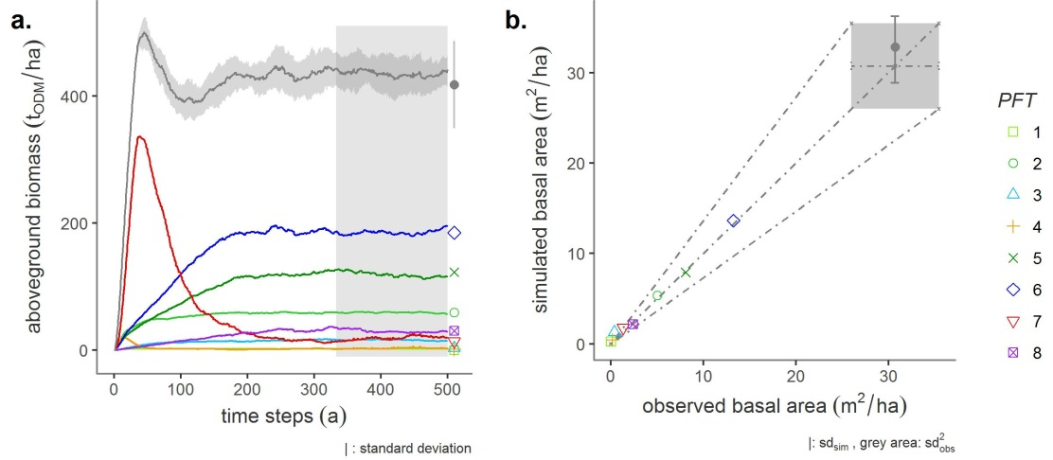

Fig 3.1: Calibration results. Comparison between the observed (dots) and simulated (line graphs) aboveground biomass development (a.) as well as the mean basal area (b.) for each plant functional type *PFT* and the total stand. Light-demanding pioneers are reddish, shade-tolerant climate species are greenish, emergent are violet, and intermediate species are bluish-colored. During model calibration, only simulation results of the years 333-1000 were taken into account. The simulated attribute values were within the range of the observed variability *sdobs*. Observed standard deviation of the attributes was then projected on the simulation results (grey area).

## 3.2 Model validation: quantification of damage by selective logging

Decisive for the model validation was to objectively check whether the usage target had been achieved. Furthermore, model validation and verification should be successful independently of each other. Therefore, different inventory data sets from the verification were used for the validation test (T1 logging plots; cp. chap. 2.2). The aim of the validation of the Paracou model was to answer our second research question: Is the calibrated forest model with the added management module able to represent the structure and dynamics of a selectively logged forest stand? The calibrated forest model served as a basis for the validation of the management module. The damage to the forest stand was defined as model parameter *daml*. The values were calculated from forest inventory data of the T1-*RIL* plots of the Paracou test site, depending on the *dbh-*classes *damdia*. The number of commercial tree species harvested and the loss of mean annual aboveground biomass were investigated as simulation results.

Fig. 3.2.a shows the temporal development of the aboveground biomass as a secondary succession after 1986. In order to make the time series (observed vs. simulated) comparable, the simulated disturbance event was assigned to the year of the observed disturbance event in 1986. Between 1986 and 2016, the difference between simulated and observed annual mean values of aboveground biomass per *PFT* should be less than the standard deviations *sd* of the observed attribute values. In the period under consideration (1987-2016), the variance of the simulated aboveground biomass deviated only little from the observed attribute values (R2 0.99084, rmse 4.63054). Only for PFT5, the model slightly underestimated biomass in the first years after selective logging until the year 2000. In contrast to the observed attribute values of PFT7 and PFT3 (fast-growing pioneer species), the simulated biomass shows a very short but significant peak (1987-1989). Simulated and observed curves stabilize themselves immediately afterwards.

Furthermore, the model of the Paracou test site estimated the exact number of trees harvested from all commercial tree species. During logging in 1986, around 33.0 tODM/ha of aboveground biomass or 10 trees per hectare were harvested on the T1-*RIL* plots in Paracou. With the simulated harvest of 10 commercially usable trees per hectare and a loss of 33.0 tODM biomass per hectare, the model provided a very good estimation of the damage and harvest. In particular, the model reacted sensitively to the parameter *daml*. In Fig. 3.2.b it is shown that the rate of damage to the remnant forest stand determined from forest inventory data decreases with increasing *dbh*.

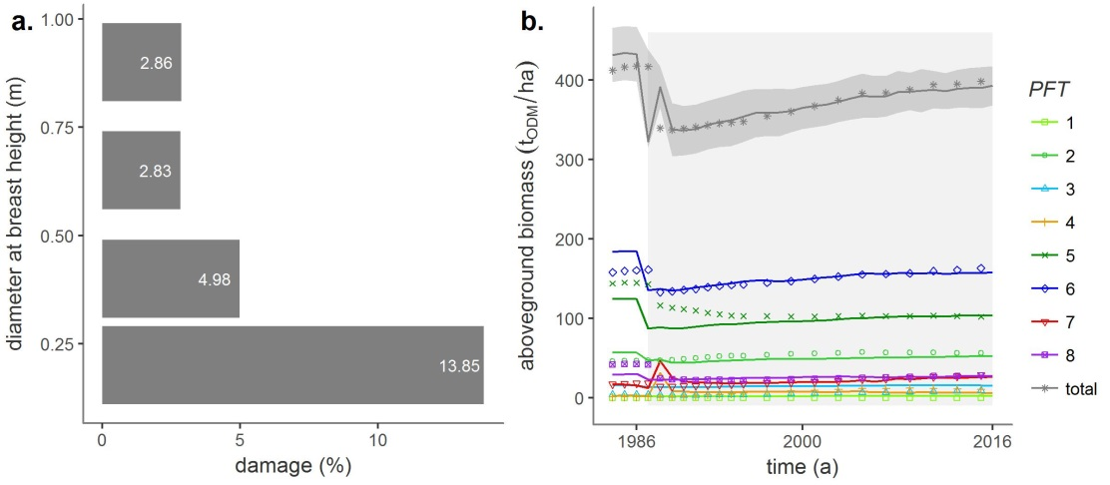

Fig 4.1: Validation results. a.) The damage to the forest stand of the Paracou test site by man and machine was defined as model parameters, and the values were calculated as a function of four log diameter classes based on forest inventory data of the T1-*RIL* plots. b.) Comparison of the temporal development of observed (dots) and simulated (line graph) aboveground biomass after the selective logging event in 1986 (grey area). Light-demanding pioneers are reddish, shade-tolerant climate species are greenish, emergent are violet, and intermediate species are bluish-colored.

## 3.3. Simulation experiment: Changes in biomass and production after damage by selective logging

The basis for the simulation experiment of this study to investigate different damages caused by selective logging was the validated forest model including the management module of the Paracou test site. Through model validation, the reliability of the model became known. The third research question was answered with the help of three simulation scenarios: How resilient is the forest stand until the end of the 21st century? The simulated logging event was assigned to the observed event in 1986 and the entire simulation period considered was between 1984 and 2100 (Fig. 3.3.a). This means that for the *RSc* scenario (undisturbed growth conditions) and the *RIL*-scenario (*reduced impact logging*), we analyzed the biomass development for a forecast period of more than 95 years. The conventional scenario *CONs*, on the other hand, was a fictitious example for which 3-16 times higher (depending on stem diameter class) damage rates through men and machine were assumed (Fig. 3.3 b).

Fig. 3.3.a shows the results of the simulation experiment of all three scenarios indicating the temporal development of the total aboveground biomass. It can be clearly seen that the 1986 disturbance in both logging scenarios was followed by an immediate decline in aboveground biomass. In comparison to the reference *RSc* in both logging scenarios, the number of trees harvested, as well as the harvested stem volume was equal: 10 stems per hectare and 52 m3/ha stem volume. Due to the different intensities of damage, however, the remaining total aboveground biomass per logging scenario differed considerably. The damaged stand volume of the *RIL* amounted to 33 tODM/ha. This was more than five times higher in the *CONs* (-179 tODM/ha). Directly after logging, the development of biomass varied according to the simulation scenario: (*i.*) The secondary succession of the *CONs* scenario was characterized by two periods during the recovery phase (1987-2050). A rapid increase in forest biomass was recorded until after about 30 years the status quo was reached for the first time. A period of increased resilience followed until about 2050, when the maximum stock biomass was reached after about 15 years (2025). In the first half of strengthened resilience, gross primary production was slower but positive. The local maximum of the stand biomass proved to be unstable, so that it fell back to the reference values (433 tODM/ha) until 2050. Subsequently, it settled to a lower secondary equilibrium level of (399 tODM/ha) until the end of the simulation period considered, in 2100. (*ii.*) During the approximately 70-year recovery phase, until 2050, the secondary succession of the total aboveground biomass of the *RIL* scenario took place with a smaller but steady gradient, so that after about 70 years (2050) the status quo was reached first time again. In the subsequent equilibrium phase (> 2050), the total aboveground biomass piled up slightly above the reference value at 450 tODM/ha. A tipping point, followed by a system collapse, did not show any of the simulation scenarios due to the damage investigated.

With regard to the research question three, changes in forest structure should be analyzed in addition to biomass dynamics. This was determined using the simulated species group composition. The results at the PFT level are shown below (Annex A1.1). The tree species composition of the secondary succession of the *RIL* scenario shifted slightly in the 70 years after the logging event: The aboveground biomass of the pioneer species in PFT6 (upper canopy layer) recovered faster than that of the climax tree species in PFT5 and PFT8 until about 2040. In undergrowth, the aboveground biomass of PFT1 remained constant. This group of species was neither used commercially nor influenced by structural variations of the forest stand. The rejuvenation rates of the intermediate species groups belonging to the higher canopy layers (PFT3 and PFT6) were between pioneer and climax species groups. After 2050, the tree species composition structure of the *RIL* scenario returned to the reference. In contrast to the *RIL* scenario, the species group composition of the *CONs* scenario was heavily shifted. This mainly concerned groups of species, with large trees of the upper two canopy layers (PFT5-PFT8). Neither PFT5 nor PFT8 reached the status quo of the reference before the logging event. Overall, the intermediary tree species of the PFT7 developed at the most dominant during the secondary succession. They grew fastest and exceeded the reference value after only 10 years. This strengthened resilience behavior of PFT7 explained the curve shape of the total biomass in the *CONs* scenario (Fig. 3.3.a).

Figure 3.3.b shows a comparison of the density functions of the gross primary production *ggp* of all three simulation scenarios starting from the moment of the logging event in 1986. While the equilibrium phase, the *gpp* of the *RIL* scenario in was close to the reference and the dispersion was low indicating a stable trend in biomass production. Median values of the scenario-dependent density distributions of both resilience phases enabled an ordinal evaluation of the scenarios. The distribution of *gpp* of the *CONs* scenario was more broadly diversified and the median value was higher than that of the reference. The median does not return to its initial state during the considered period of time. Note that with normally distributed data, the median corresponds to the arithmetic mean.

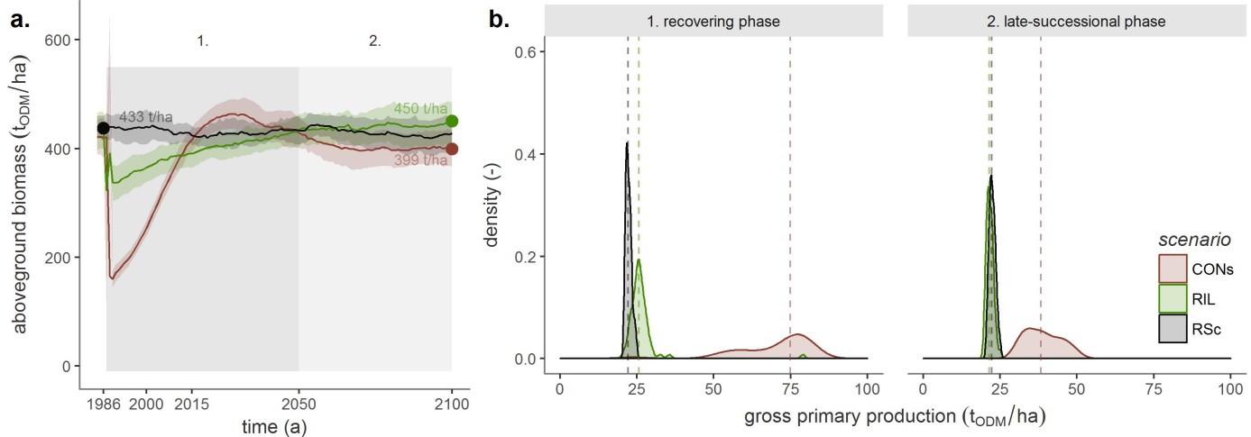

Fig 4.1: Simulation experiment. a.) Results for the scenario settings used in FORMIND, simulated over 116 years for the forest stand of Paracou (line graphs). Starting from an equilibrium phase of the primary succession, the development of the aboveground biomass after a logging event (1986) until the end of the 21st century is presented. The dots indicate the averaged values of the simulation results either for a 50-year spin-up period (primary succession) or secondary succession. b.) Scenario-dependent density distributions of gross primary production after selective logging in 1986, shown for the two phases of secondary succession: recovering phase (1987-2050) and late-successional phase (2051-2100). Median values (dashed lines) enable an ordinal evaluation of the scenarios.

# 4. Discussion

## 4.1. Simulation experiment

With the dynamic, individual-oriented forest model of the Paracou test site, we simulated the secondary succession after selective logging in two scenarios, in which different damage intensities were assumed. The biomass production of these two scenarios was compared with a reference showing undisturbed forest growth. Subsequently, we analyzed the simulation results of aboveground biomass production at both forest stand and species group level and evaluated their resilience and structural composition. For the *RIL* scenario (*reduced impact logging*) we have calculated the parameter values of damage for each stem diameter class from the forest inventory data of the T1-*RIL* plots (cf. Fig. 3.3b). This type of damage only reflected the influence of man and machine on the remaining forest stand. Damage to the remaining forest stand caused by falling trees or the development of skidding trails was not taken into account. In addition, the fall direction of the logged trees was controlled and potentially harvest-able trees (so-called future trees) remained undamaged in the *RIL*. The scenario *CONs* (conventional logging) was a fictitious scenario that was created for further discussion. The damage intensity per stem diameter class was assumed to be significantly higher than that of *RIL*. In addition, the fall direction of logged trees was not controlled and future trees could be damaged.

On the basis of the extrapolation of the biomass production of the forest stand beyond the period of the forest inventory data of Paracou, we were able to make long-term statements about the structure and dynamics of the secondary succession. The resilience of biomass production could be used as an indicator for the definition of sustainable silviculture strategies. This was possible at both the stand and species group level. The species composition of forest ecosystems varies over time, depending on natural disturbances and climate fluctuations (Thompson 2011). The fluctuations, however, remain more or less constant, within the limits of natural variations, related to a state of equilibrium (Sakschewski et al. 2016). In a state of equilibrium, forests can produce a variety of products and services that can be useful to mankind (Simula 2009). A change in forest state results from a loss of resilience, with a partial or complete shift to an ecosystem type other than that expected for the location. Such changes in state lead to a reduction in the production of goods and services. Therefore, a change in species composition can be used as an indicator of degradation (Thompson 2011). Our results of the simulation experiment on disturbing the growth dynamics and structure of Paracou's forest showed that the conservation of biodiversity and species composition is crucial for sustainable forest management and a key factor for the long-term preservation of the forest ecosystem. The management module could be used to estimate the harvest yield of a logging event. This was possible because the forest model calculates on the basis of individual trees.

In summary, we come to the conclusion that *RIL* strategies are advantageous for the resilience of the forest stand. A similar species composition as well as biomass balance could already be achieved about 70 years after the event, as in the status quo. This is important against the background of carbon fixation and biodiversity debates. This is important against the background of carbon fixation and biodiversity debates. The yield of the conventional scenario *CONs* was just as high as that of the *RIL* scenario, but damaged the remaining forest stand in such a way that it produced less biomass in the secondary equilibrium until 2100. The simulation experiment also showed that the structure of the forest stand was changed so much after the intervention of *CONs* that a different type of forest would result.

## 4.2. Model performance

The challenge of this study was to map the succession of the forest structure at Paracou's test site as accurately as possible using the model. This was important in order to investigate different logging scenarios depending on the application. In order to be able to make a statement about the efficiency of our simulation experiment, the parameterization of the forest model was first calibrated with field data from forest inventories for the attributes aboveground biomass and basal area. FORMIND is individual-based; i. e. the tree growth of individual trees belonging to plant functional types *PFT* could be dynamically simulated. In order to be able to make a statement about the performance of our simulation experiment, the parameterization of the forest model was first calibrated with field data from forest inventories for the attributes aboveground biomass and tree size-tree number-distribution. A management module was then added. The simulation results of logging of the T1-*RIL* were validated with other inventory data from the Paracou test site. The deviations between simulated and observed biomass production differed by less than the observed variability (*sd*) for the total stand. The forest structure was also well represented. Proof of this was the high degree of consistency between the temporal development of the species group composition (cf. Fig. 3.1; 3.2.a).

In summary, one reason for the very good model performance was the excellent data basis from the forest stands at the Paracou test site: the tree species grouping into *PFT*s and the calculation of parameter values for both geometric relationships of trees and model processes (e.g. tree growth rates, mortality rates) were calculated and not only estimated (Appendix A1, Tab. A1.1). Another reason was that the calibration and fine-tuning took into account the simulated and observed number of trees per size class. The tree size-tree number-distribution explicitly reflected the structure of Paracou's forest stand. It was important to select the corresponding target function for the *DDS* procedure (Lehmann and Huth 2015).

## 4.3. Conclusion and perspectives

With this study, an attempt was made to extend the current state of research both methodologically and scientifically. Methodologically, there was uncertainty regarding the model performance of FORMIND, as no validation of the simulation results of selective logging with field data has been carried out so far. The question of to what extent different disturbance intensities in selective logging can influence the future development of a forest stand was scientifically still open. Our goal was to contribute to the development of sustainable forest management strategies in the Amazon forest. At the global level, the protection of the Amazon rain forest contributes significantly to the conservation of biodiversity and the preservation of an important component in the global carbon cycle. In addition to other ecosystem services, the Amazon provides useful resources such as timber. High deforestation rates have long been contributing to the degradation of its forests [IPCC (2014); Global Forest Watch 2014]. In order to help solve this issue, we have chosen a mechanistic approach in which the forest structure and growth dynamics can be assessed not only in the short term, but also in the long term by linking observations (forest inventory data from Paracou in French Guiana) and model simulations (FORMIND forest model with management module). A tool was created to investigate selective logging scenarios by validating short-term simulation results with field data. With regard to methodological and scientific findings, the following questions have to be answered or clarified: How do repeated deforestation events affect the resilience and species composition? What role does the specification of minimum trunk diameters of logged trees play in this context? Damage to forest stand caused by deforestation events, which damage intensities result for skid roads, overthrow, falling trees, thinning, fuel wood. etc. What influence do environmental factors such as climate have on biomass growth and the structure of a production forest? Can studies such as these be extended to the entire Amazon region for the Paracou site?

In the future, we intend to develop reduced impact strategies by means of further simulation experiments showing the best possible relationship between maximum yield and minimum impact of logging on forest growth. Furthermore, we intend to evaluate the effects of a wider range of management strategies on long-term forest growth dynamics by implementing an updated version of the management module into the model architecture. This methodological approach will allow the development of silviculture strategies that are more economic and ecological friendly. Knowledge gained through such simulation experiments may help decision-making (REDD+ and FSC-labeling).

# Acknowledgements

We want to thank *Prof. Dr. Stéphane Traissac* very much for his valuable comments and support regarding the model parameterization as well as *Laurent Descroix* for his helpful discussion on the silviculture of French Guiana's production forests. We also want to thank the anonymous reviewers for their valuable comments. We gratefully acknowledge the *German Federal Environmental Foundation - DBU* for funding *Ulrike Hiltner*'s PhD project AZ 20015/398.

# Appendix A1

Additional information on the parameterization process of the FORMIND forest model including management module and detailed lists of the parameter values used are documented below. Please, find a detailed model description in Fischer et al. (2016) or on the [homepage www.FORMIND.org](C:\\Arbeit\\Diss\\TP3_Publikationen\\ArtikelTwo\\www.formind.org).

## A1.1 The model's parameterization

**The model landscape** is defined as squared area from 1 ha up to several km2 (in this study 16 ha) being composed of such squared patches (Fig. A1.1.1).

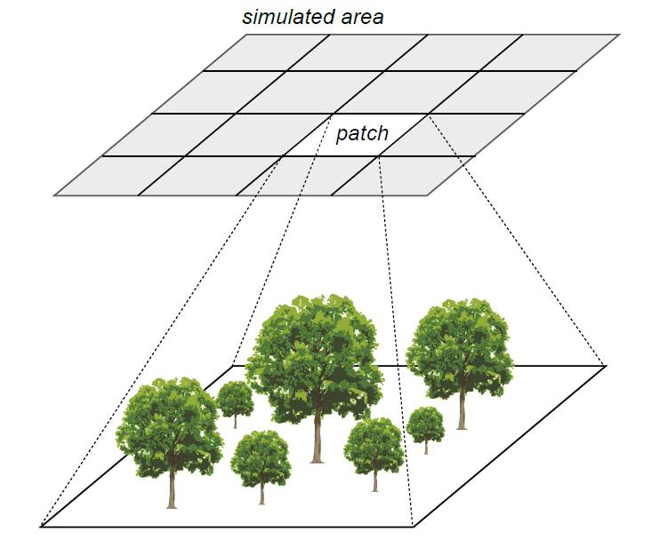

Fig A1.1.1: The FORMIND model's patch structure. The model landscape is defined as squared area from 1 ha up to several km2 (in this study 16 ha) being composed of squared patches (20 m x 20 m). Patches obtain an explicit spatial position, while the trees within a patch are positioned explicitly depending on the light climate on the ground.

**Allometric relations of the trees** were modeled on a tree-level for all stem diameter measurements. Undetermined tree species were gathered and their parameter values were averaged. Since wood density is related to the forest stand dynamics, we assigned all available wood densities after Chave et al. (2009) and Zanne et al. (2009) to the tree species and completed undetermined ones by deriving mean wood densities that were genre-, family- or study site-specific. All derived geometric relations were then aggregated group-specifically to model tree growth individually. The functional relations used are documented in Tab. A1.1.1 and the parameter values can be found in Tab. A1.1.2. Throughout the study corrected values of *dbh*-measurements were used (cf. Appendix A1.2).

Tab. A1.1.1: Functional relations used in this study with *agb*: aboveground biomass; *cd*: crown diameter; *circ*: stem circumference; *cl*: crown length; *dbh*: stem diameter at breast height; *dinc*: stem diameter increment; *f*: form factor; *h*: growth height; *lai*: leaf area index; *m*: stem based mortality rate; $ρ$: wood density; *tr*: fraction of stem biomass to total aboveground biomass. Further basic functions are listed in Fischer et al. (2016).

|  |  |
| --- | --- |
| geometric relation | function |
| stem circumference-dbh | $$dbh(circ)=circ/π$$ |
| aboveground biomass-dbh | $$agb(dbh)=π/4*ρ/tr*dbh^{2}*h*f$$ |
| crown diameter-dbh | $$cd(dbh)=cd_{0}*dbh^{cd_{1}}$$ |
| crown length-height | $$cl(h)=cl_{0}*h$$ |
| stem diameter increment-dbh | $$dinc(dbh)=a_{0}*dbh*(1-dbh/dbh_{max})*exp(-a_{1}*dbh)$$ |
| form factor-dbh | $$f(dbh)=f_{0}*dbh^{f_{1}}$$ |
| tree height-dbh | $$h(dbh)=h_{0}*dbh/(h_{1}+dbh)$$ |
| leaf area index-dbh | $$lai(dbh)=l_{0}*dbh^{l_{1}}$$ |
| mortality-dbh | $$m(dbh)=m_{0}*e^{-m_{1}*dbh}$$ |

Tab. A1.1.2: *PFT*-specific parameter values and their meaning or unit of the forest model FORMIND used for the Paracou test site.

|  |  |  |  |  |  |  |  |  |  |  |  |
| --- | --- | --- | --- | --- | --- | --- | --- | --- | --- | --- | --- |
| parameter | pescription | unit | PFT1 | PFT2 | PFT3 | PFT4 | PFT5 | PFT6 | PFT7 | PFT8 | reference |
| light and establishment |  |  |  |  |  |  |  |  |  |  |  |
| k | light extinction coefficient | - | 0.7 | 0.7 | 0.7 | 0.7 | 0.7 | 0.7 | 0.7 | 0.7 | Köhler et al. (2003) |
| nseed | global number of seeds | 1 ha-1 | 2 | 27 | 2 | 15 | 14 | 16 | 20 | 2 | fine-tuned |
| iseed | min. light intensity to establish | - | 0.01 | 0.01 | 0.05 | 0.20 | 0.01 | 0.02 | 0.15 | 0.01 | Köhler et al. (2003) |
| geometry |  |  |  |  |  |  |  |  |  |  |  |
| hmax | max. growth height | m | 16.50 | 34.22 | 34.61 | 34.85 | 40.40 | 39.96 | 38.58 | 39.06 | derived from inventory data |
| h0 | height-dbh-relation | - | 47.0 | 47.0 | 47.0 | 47.0 | 47.0 | 47.0 | 47.0 | 47.0 | calculated from Molto, Hérault, Boreux, et al. (2014b); Molto, Hérault, Boreux, et al. (2014a) |
| h1 | height-dbh-relation | - | 0.276 | 0.276 | 0.276 | 0.276 | 0.276 | 0.276 | 0.276 | 0.276 | calculated from Molto, Hérault, Boreux, et al. (2014b); Molto, Hérault, Boreux, et al. (2014a) |
| cd0 | crown diameter-dbh-relation | - | 13.12 | 13.12 | 13.12 | 13.12 | 13.12 | 13.12 | 13.12 | 13.12 | calculated from Jucker et al. (2017) |
| cd1 | crown diameter-dbh-relation | - | 0.59 | 0.59 | 0.59 | 0.59 | 0.59 | 0.59 | 0.59 | 0.59 | calculated from Jucker et al. (2017) |
| l0 | lai-dbh-relation | - | 2.0 | 2.0 | 2.0 | 2.0 | 2.0 | 2.0 | 2.0 | 2.0 | Köhler et al. (2003) |
| l1 | lai-dbh-relation | - | 0.0 | 0.0 | 0.0 | 0.0 | 0.0 | 0.0 | 0.0 | 0.0 | Köhler et al. (2003) |
| f0 | form factor-dbh-relation | - | 0.425 | 0.425 | 0.425 | 0.425 | 0.425 | 0.425 | 0.425 | 0.425 | derived from inventory data |
| f1 | form factor-dbh-relation | - | -0.18 | -0.18 | -0.18 | -0.18 | -0.18 | -0.18 | -0.18 | -0.18 | Fischer et al. (2014) |
| cl0 | crown length factor-height-relation | - | 0.358 | 0.358 | 0.358 | 0.358 | 0.358 | 0.358 | 0.358 | 0.358 | Köhler et al. (2003) |
| $$σ$$ | fraction of stem biomass-total biomass | - | 0.7 | 0.7 | 0.7 | 0.7 | 0.7 | 0.7 | 0.7 | 0.7 | derived from inventory data |
| biomass and productivity |  |  |  |  |  |  |  |  |  |  |  |
| $$ρ$$ | wood density | $$t*m^{-1}$$ | 0.76 | 0.77 | 0.66 | 0.55 | 0.83 | 0.73 | 0.56 | 0.62 | calculated from Chave et al. (2009);Zanne et al. (2009) |
| M | transmission coefficient of leafs | - | 0.1 | 0.1 | 0.1 | 0.1 | 0.1 | 0.1 | 0.1 | 0.1 | Larcher (1994) |
| G | gross productivity to respiratory costs | - | 0.2 | 0.2 | 0.2 | 0.2 | 0.2 | 0.2 | 0.2 | 0.2 | Rico fragen nach Quelle |
| $$α$$ | slope of light response curve | $$μmol_{CO_{2}}*μmol_{photons}^{-1}$$ | 0.043 | 0.043 | 0.035 | 0.086 | 0.043 | 0.043 | 0.086 | 0.043 | Köhler et al. (2003) |
| pmax | maximum leaf photosynthesis | $$μmol_{CO_{2}}*(m^{2}*s)^{-1}$$ | 1.12 | 0.55 | 2.00 | 20.59 | 1.35 | 1.50 | 27.00 | 1.46 | fine-tuned |
| gmax | maximum annual stem diameter increment | m/yr | 0.011 | 0.018 | 0.017 | 0.014 | 0.025 | 0.013 | 0.022 | 0.031 | derived from inventory data, fine-tuned |
| gdbhmax | maximum stem diameter | - | 0.24 | 0.17 | 0.12 | 0.11 | 0.30 | 0.11 | 0.17 | 0.37 | derived from inventory data, fine-tuned |
| mortality |  |  |  |  |  |  |  |  |  |  |  |
| mmean | background mortality rate | - | 0.01 | 0.01 | 0.013 | 0.02 | 0.01 | 0.01 | 0.02 | 0.01 | derived from inventory data |
| fallP | probability of dead tree to fall | - | 0.5 | 0.5 | 0.5 | 0.5 | 0.5 | 0.5 | 0.5 | 0.5 | derived from inventory data |
| management module |  |  |  |  |  |  |  |  |  |  |  |
| commspec | proportion of commercially logged species | - | 0.0 | 0.0362 | 0.2393 | 0.0865 | 0.5718 | 0.5531 | 0.3311 | 0.2706 | derived from inventory data |
| logdbh | cutting threshold of mean stem diameter | [m] | 0.55 | 0.55 | 0.55 | 0.55 | 0.55 | 0.55 | 0.55 | 0.55 | derived from inventory data |

**Calibration, and fine tuning.** The parameters describing the photosynthesis (*pmax*), the slope of the light response curve ($α$), the maximum stem diameter growth rates (*gmax, gdbhmax*), and the number of seeds (*Nseed*) are important for the succession of the forest stand and the composition of the tree species. These parameters were numerically calibrated and fine-tuned using the dynamically dimensioned search *DDS* (Lehmann and Huth 2015). The simulation results of the model (aboveground biomass, stem number, basal area) were calibrated using aggregated criteria derived from Paracou's forest inventory data of the T0-control plots (Fig. A1.2.1). The Paracou data represent a forest at its equilibrium state. The *DDS* method ran with $1.0*{10}^{6}$ iterations and a search radius of 0.2. The cost function computed the standard error *Q* between the observed *o* and modeled *m* values as follows:

$$Q=Q_{B}+Q_{N}=\sum_{p}{(}ω_{Bp}*|Q_{Bp}|)+\sum_{p}{(}\sum_{d}{(}ω_{Dd}*|Q_{Nd}|)*ω_{Bp})=\sum_{p}{(}B_{op}/B_{ot}*|(B_{mp}-B_{op})/B_{op}|+\sum_{p}{(}\sum_{d}{(}D_{d}/D_{t}*|(N_{md}-N_{od})/N_{od}|)*B_{op}/B_{ot})$$

with *QB* and *QN* as weighted relative errors and the indices representing the aboveground biomass *B* and stem numbers *N*. *QB* and *QN* equal the sums over all absolute values of their relative errors multiplied with weighing factors $ω$. The relative errors between the observed *o* and modeled *m* values of *B* or *N* were calculated either for each plant functional type *p* or each stem diameter class *d* (class width = 0.1 m). The weights $ω_{Bp}$ and $ω_{Dd}$ were determined regarding either the *PFT*'s observed aboveground biomasses or the mean stem numbers *D* per stem diameter class *d* as fraction of their total sums *t*. The weighting of the *PFT*'s aboveground biomasses and the stem numbers should ensure that the model output, necessary for answering the research questions, was modeled precisely. Decisive for the quality of the cost function were the appropriateness of the weighting factors $ω$. This led to the fact that the aboveground biomass of more dominant *PFT*s and the frequency of tall trees with a large stem diameter had a greater impact on the simulation result during the parameter set's fine-tuning. Ranges of the fine-tuned parameters are shown in Tab. A1.1.3.

Tab. A1.1.3: Model calibration and fine-tuning. *PFT*-specific ranges of the parameter values that were fine-tuned using the dynamically dimensioned search *DDS* (Lehmann and Huth 2015).

|  |  |  |
| --- | --- | --- |
| pft | range of nseed | range of pmax |
| 1 | [1; 10] | [0.9; 3.0] |
| 2 | [1; 35] | [0.4; 3.0] |
| 3 | [1; 60] | [3.0; 10.0] |
| 4 | [15; 100] | [10.0; 25.0] |
| 5 | [1; 25] | [0.9; 3.0] |
| 6 | [1; 60] | [3.0; 10.0] |
| 7 | [15; 100] | [10.0; 28.0] |
| 8 | [1; 25] | [0.9; 3.0] |

The values for *pmax* and *nseed* are based on knowledge from previous studies (e.g. (Hiltner et al. 2016; Fischer et al. 2016; Fischer et al. 2014; Köhler et al. 2003)). It was important that the calibrated parameters did not reach the upper or lower limits. All parameter values used in the parameterization of the FORMIND forest model are documented in Table A1.1.2.

Due to this approach, the forest model of FORMIND was calibrated against $136$ data points originating from the forest inventories: taking eight *PFT*s by stem numbers of 16 stem diameter classes and their aboveground biomass of the cost function. Extensive preliminary testing of cost functions showed that the chosen criteria were the most effective within this study. Fig. A1.1.2 shows the results of the fine-tuning by presenting the total forest stand's tree size distribution. For trees with a *dbh* smaller than 0.4 m, the number of trees was slightly overestimated by the model, whereas the number of larger trees was very well recorded.

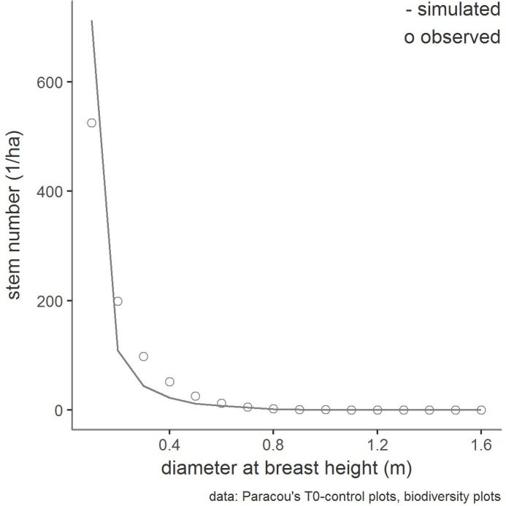

Fig A1.1.2: Model calibration. Comparison of the simulated and observed mean root number tree size distribution of the entire forest stand. The mean values of the observations were calculated from the forest inventory data of the T0 control areas and biodiversity areas (cf. A1.2.1) of the period 1984-2016. The simulated mean values were averaged over 16 ha and over the years 333-1000, assuming that the forest was in equilibrium of a mature forest.

**The simulation experiment** was intended to investigate damages of selective logging on forest growth conditions. Fig. A1.1.3 shows the development of aboveground biomass for the simulation experiment group-specifically.

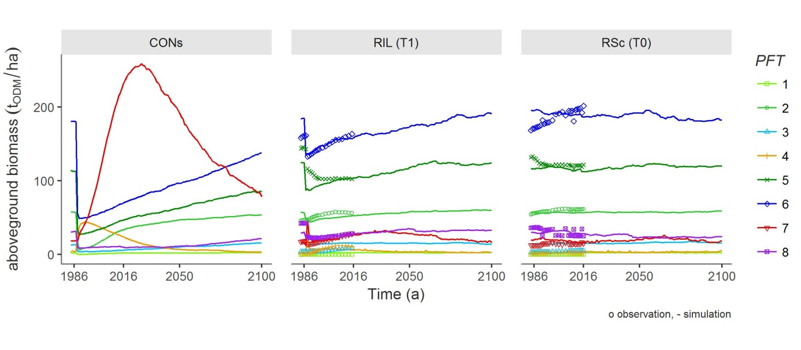

Fig. A1.1.3: Simulation results of all scenarios on *PFT*-level. Points represent observed mean aboveground biomass calculated from forest inventory data regarding different successional stages. Time series represent mean *agb* and *sn* of simulation results starting from bare ground per hectare with standard deviations of 10 ha.

## A1.2 The experimental design

**The experimental design** at the test site is shown schematically in the global map of Paracou (Fig. A1.2.1).

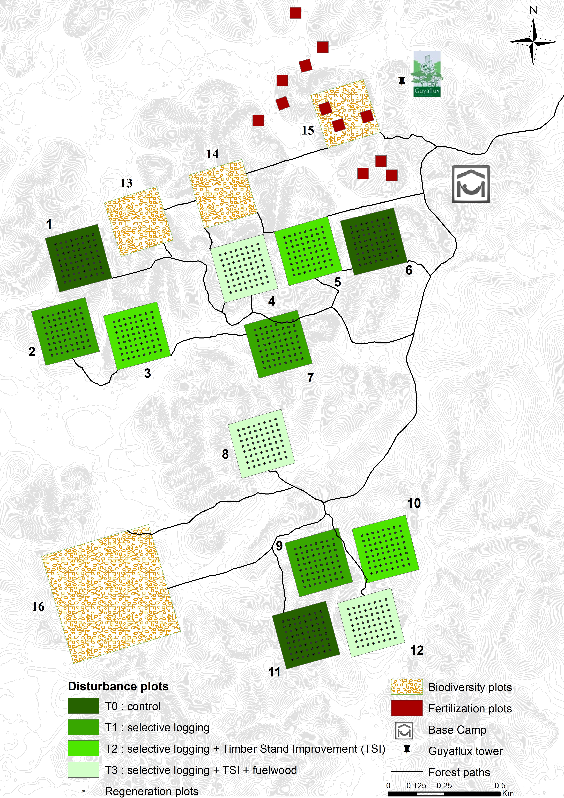 (**???**) Fig A1.2.1: The global map of Paracou's experimental design (CIRAD 2016). To parameterize and calibrate the forest model of FORMIND we used forest inventory data of the T0-control plots and biodiversity plots. The parameterization and validation of FORMIND's management module is based on forest inventory data of the T1-logging plots.

**The correction of *dbh* measurements.** In some cases the normal *dbh* measurement was not possible, so that the measuring point was adjusted according to four rules. The type of rule shows tab. A1.2.1. In order to eliminate bias caused by such an adjustment of the measuring points, a correction of the primary circumferential measurement was calculated, which was used in the course of the study.

Tab. A1.2.1: Coding for the measuring point of the trunk circumference [cm] in Paracou's forest inventory data set.

|  |  |
| --- | --- |
| coding | meaning |
| 0 | normal measure at 1.3 m |
| 1 | elevated measure at 0.5 m |
| 2 | elevated measure at 1.0 m |
| 3 | elevated measure at 1.5 m |
| 4 | tree with irregular stem |

**The types of damage through logging.** It was possible to model logging damages that were defined as the damage to the remaining forest stand. We obtained information about the proportion of damaged trees from the total number of trees, from the inventory data of the T1-*RIL* plots of Paracou (cf. Fig. A1.2.1). Table A1.2.1 shows the coding of damage through logging.

Tab. A1.2.2.: Coding for the type of damage (code_resume) and its meaning in Paracou's forest inventory data set. Code alive indicates whether a tree is still alive or not (1: true, 0: false).

|  |  |  |
| --- | --- | --- |
| coding alive | coding measure | meaning |
| 0 | 1 | dead tree, destroyed through overthrow of logged trees |
| 0 | 5 | dead tree, destroyed through man and machine |
| 0 | 8 | dead tree, destroyed after exploitation |

In FORMIND the parameter *dam1* was calculated as fraction of the sum of counted stems *n* of dead trees through logging and all trees on the T1-*RIL*-plots *nt*, with the indices indicating the type of damage *code alive|code measure*:

$dam dia =(n_{0|1}+n_{0|5}+n_{0|8})/n_{t}$.

# Appendix A2

**Software used.** To process the data of Paracou's forest inventories as well as the simulation results of FORMIND (Fischer et al. 2016), version 3.4.1 of the R statistical software (R Core Team, 2017) with the packages 'tidyverse' v1.1.1 (Wickham, 2017), 'modelr' v0.1.0 (Wickham, 2016), 'splines' (R Core Team, 2017), 'bookdown' v.0.4 (Xie, 2017) were used.

MOOP v0.21 was used (Lehmann and Huth 2015) during the fine-tuning of the FORMIND forest model.

# References

Global Forest Watch, 2014. World Resources Institute. Accessed online (2017-08-20): www.globalforestwatch.org.

CIRAD, 2016. Paracou Research Station, a large scale forest disturbance experiment in Amazonia. Experimental Design. Accessed online (2017-10-22): <https://paracou.cirad.fr/experimental-design>.

PEFC International, 2017. PEFC - Caring for our forests globally. The French Guianese forest-based sector strengthens its commitment to PEFC certification. Accessed online (2017-10-23): <https://pefc.org/news-a-media/general-sfm-news/1200-the-french-guianese-forest-based-sector-strengthens-its-commitment-to-pefc-certification>.

Leyer, I. and Wesche, K., 2007. Multivariate Statistik in der Ökologie. Springer, Berlin, Heidelberg, pp. 232.

Bennett, Neil D., Barry F.W. Croke, Giorgio Guariso, Joseph H.A. Guillaume, Serena H. Hamilton, Anthony J. Jakeman, Stefano Marsili-Libelli, et al. 2013. “Characterising performance of environmental models.” *Environmental Modelling & Software* 40: 1–20. doi:[10.1016/j.envsoft.2012.09.011](https://doi.org/10.1016/j.envsoft.2012.09.011).

Blaser, Juergen, Alastair Sarre, Duncan Poore, and Steven Johnson. 2011. *Status of Tropical Forest Management 2011*. Vol. 38. June. doi:[10.1017/S0032247400051135](https://doi.org/10.1017/S0032247400051135).

Bonan, G. B. 2008. “Forests and Climate Change: Forcings, Feedbacks, and the Climate Benefits of Forests.” *Science* 320 (5882): 1444–9. doi:[10.1126/science.1155121](https://doi.org/10.1126/science.1155121).

Brienen, R. J. W., O. L. Phillips, T. R. Feldpausch, E. Gloor, T. R. Baker, J. Lloyd, G. Lopez-Gonzalez, et al. 2015. “Long-term decline of the Amazon carbon sink.” *Nature* 519 (7543): 344–48. doi:[10.1038/nature14283](https://doi.org/10.1038/nature14283).

Chave, Jerome, David Coomes, Steven Jansen, Simon L. Lewis, Nathan G. Swenson, and Amy E. Zanne. 2009. “Towards a worldwide wood economics spectrum.” *Ecology Letters* 12 (4): 351–66. doi:[10.1111/j.1461-0248.2009.01285.x](https://doi.org/10.1111/j.1461-0248.2009.01285.x).

Clark, Michael Rawson, and Joelyn Sarrah Kozar. 2011. “Comparing sustainable Forest Management certifications standards: A Meta-Analysis.” doi:[10.5751/ES-03736-160103](https://doi.org/10.5751/ES-03736-160103).

Danielsen, Finn, Margaret Skutsch, Neil D. Burgess, Per Moestrup Jensen, Herizo Andrianandrasana, Bhaskar Karky, Richard Lewis, et al. 2011. “At the heart of REDD+: A role for local people in monitoring forests?” *Conservation Letters* 4 (2): 158–67. doi:[10.1111/j.1755-263X.2010.00159.x](https://doi.org/10.1111/j.1755-263X.2010.00159.x).

Dourdain, Aurélie, and Bruno Hérault. 2015. “Allometric equations in the Guiana Shield: REDD+ for the Guiana Shield.” Paracou: CIRAD.

Durst, P.B, P.J McKenzie, C.L Brown, and S Appanah. 2006. “Challenges facing certification and eco-labelling of forest products in developing countries.” *International Forestry Review* 8 (2): 193–200. doi:[10.1505/ifor.8.2.193](https://doi.org/10.1505/ifor.8.2.193).

D’Amato, Anthony W., John B. Bradford, Shawn Fraver, and Brian J. Palik. 2011. “Forest management for mitigation and adaptation to climate change: Insights from long-term silviculture experiments.” *Forest Ecology and Management* 262 (5): 803–16. doi:[10.1016/j.foreco.2011.05.014](https://doi.org/10.1016/j.foreco.2011.05.014).

Fischer, Rico, Amanda Armstrong, Herman H. Shugart, and Andreas Huth. 2014. “Simulating the impacts of reduced rainfall on carbon stocks and net ecosystem exchange in a tropical forest.” *Environmental Modelling & Software* 52 (February): 200–206. doi:[10.1016/j.envsoft.2013.10.026](https://doi.org/10.1016/j.envsoft.2013.10.026).

Fischer, Rico, Friedrich Bohn, Mateus Dantas de Paula, Claudia Dislich, Jürgen Groeneveld, Alvaro G. Gutiérrez, Martin Kazmierczak, et al. 2016. “Lessons learned from applying a forest gap model to understand ecosystem and carbon dynamics of complex tropical forests.” *Ecological Modelling* 326: 124–33. doi:[10.1016/j.ecolmodel.2015.11.018](https://doi.org/10.1016/j.ecolmodel.2015.11.018).

Foley, Jonathan A., Gregory P. Asner, Marcos Heil Costa, Michael T. Coe, Ruth DeFries, Holly K. Gibbs, Erica A. Howard, et al. 2007. “Amazonia revealed: Forest degradation and loss of ecosystem goods and services in the Amazon Basin.” doi:[10.1890/1540-9295(2007)5[25:ARFDAL]2.0.CO;2](https://doi.org/10.1890/1540-9295(2007)5[25:ARFDAL]2.0.CO;2).

Gibbs, Holly K, Sandra Brown, John O Niles, and Jonathan A Foley. 2007. “Monitoring and estimating tropical forest carbon stocks: making REDD a reality.” *Environmental Research Letters* 2 (4): 045023. doi:[10.1088/1748-9326/2/4/045023](https://doi.org/10.1088/1748-9326/2/4/045023).

Gourlet-Fleury, S, B Ferry, J-F. Molino, P Petronelli, and L Schmitt. 2004. “Paracou expérimental plots : keys features.” In *Ecology and Management of a Neotropical Rainforest : Lessons Drawn from Paracou, a Long-Term Experimental Research Site in French Guiana*, 3–60.

Hiltner, Ulrike, Achim Bräuning, Aster Gebrekirstos, Andreas Huth, and Rico Fischer. 2016. “Impacts of precipitation variability on the dynamics of a dry tropical montane forest.” *Ecological Modelling* 320 (January): 92–101. doi:[10.1016/j.ecolmodel.2015.09.021](https://doi.org/10.1016/j.ecolmodel.2015.09.021).

Huth, Andreas, Martin Drechsler, and Peter Köhler. 2004. “Multicriteria evaluation of simulated logging scenarios in a tropical rain forest.” *Journal of Environmental Management* 71 (4): 321–33. doi:[10.1016/j.jenvman.2004.03.008](https://doi.org/10.1016/j.jenvman.2004.03.008).

IPCC. 2014. *Climate Change 2014: Impacts, Adaptation, and Vulnerability. Part A: Global and Sectoral Aspects. Contribution of Working Group II to the Fifth Assessment Report of the Intergovernmental Panel on Climate Change.* Edited by Field, C.B., V.R. Barros, D.J. Dokken, K.J. Mach, M.D. Mastrandrea, T.E. Bilir, M. Chatterjee, K.L. Ebi, Y.O. Estrada, R.C. Genova, B. Girma, E.S. Kissel, A.N. Levy, S. MacCracken, P.R. Mastrandrea and L.L. White. Cambridge, United Kingdom; New York, NY, USA: Cambridge University Press. <http://ipcc-wg2.gov/AR5/report/full-report/>.

Jucker, Tommaso, John Caspersen, Jérôme Chave, Cécile Antin, Nicolas Barbier, Frans Bongers, Michele Dalponte, et al. 2017. “Allometric equations for integrating remote sensing imagery into forest monitoring programmes.” *Global Change Biology* 23 (1): 177–90. doi:[10.1111/gcb.13388](https://doi.org/10.1111/gcb.13388).

Kammesheidt, Ludwig, Peter Köhler, and Andreas Huth. 2002. “Simulating logging scenarios in secondary forest embedded in a fragmented neotropical landscape.” *Forest Ecology and Management* 170 (1-3): 89–105. doi:[10.1016/S0378-1127(01)00783-6](https://doi.org/10.1016/S0378-1127(01)00783-6).

Köhler, Peter, Jérôme Chave, Bernard Riéra, and Andreas Huth. 2003. “Simulating the long-term response of tropical wet forests to fragmentation.” *Ecosystems* 6 (2): 114–28. doi:[10.1007/s10021-002-0121-9](https://doi.org/10.1007/s10021-002-0121-9).

Kurier, Holz. 2000. “Query whether the comparison between the PEFC and FSC is reliable with respect to competition in certification.” *Holz - Kurier* 55 (33): 14. [https://www.scopus.com/inward/record.uri?eid=2-s2.0-3342950351{\&}partnerID=40{\&}md5=a1f8f0a65b1418afd9c7035f1be3da4c](https://www.scopus.com/inward/record.uri?eid=2-s2.0-3342950351%7b\&%7dpartnerID=40%7b\&%7dmd5=a1f8f0a65b1418afd9c7035f1be3da4c).

Larcher, W. 1994. “Ökophysiologie der Pflanzen.” *UTB*, 394.

Lehmann, Sebastian, and Andreas Huth. 2015. “Fast calibration of a dynamic vegetation model with minimum observation data.” *Ecological Modelling* 301. Elsevier B.V.: 98–105. doi:[10.1016/j.ecolmodel.2015.01.013](https://doi.org/10.1016/j.ecolmodel.2015.01.013).

Long, Andrew. 2013. “REDD + , Adaptation , and sustainable forest management : toward effective polycentric global forest governance.” *Tropical Conservation Science* 6 (3): 384–408. <http://ssrn.com/abstract=2186737>.

Malhi, Yadvinder, and John Grace. 2000. “Tropical forests and atmospheric carbon dioxide.” *Trends in Ecology & Evolution* 15 (8): 332–37. doi:[10.1016/S0169-5347(00)01906-6](https://doi.org/10.1016/S0169-5347(00)01906-6).

Molina, Mario J. 2009. “Planetary boundaries: Identifying abrupt change.” *Nature Reports Climate Change*, no. 0910: 115–16. doi:[10.1038/climate.2009.96](https://doi.org/10.1038/climate.2009.96).

Mollicone, D, A Freibauer, E D Schulze, S Braatz, G Grassi, and S Federici. 2007. “Elements for the expected mechanisms on ‘reduced emissions from deforestation and degradation, REDD’ under UNFCCC.” *Environmental Research Letters* 2 (4): 045024. doi:[10.1088/1748-9326/2/4/045024](https://doi.org/10.1088/1748-9326/2/4/045024).

Molto, Q., B. Hérault, J. J. Boreux, M. Daullet, A. Rousteau, and V. Rossi. 2014a. “Supplement of: Predicting tree heights for biomass estimates in tropical forests -A test from French Guiana.” *Biogeosciences* 11 (12): 3121–30. doi:[10.5194/bg-11-3121-2014](https://doi.org/10.5194/bg-11-3121-2014).

Molto, Q., B. Hérault, J.-J. Boreux, M. Daullet, A. Rousteau, and V. Rossi. 2014b. “Predicting tree heights for biomass estimates in tropical forests &ndash; a test from French Guiana.” *Biogeosciences* 11 (12): 3121–30. doi:[10.5194/bg-11-3121-2014](https://doi.org/10.5194/bg-11-3121-2014).

Myers, Norman, Norman Myers, Russell a Mittermeier, Russell a Mittermeier, Gustavo a B Fonseca, G a B Fonseca, Jennifer Kent, and Jennifer Kent. 2000. “Biodiversity hotspots for conservation priorities.” *Nature* 403 (6772): 853–8. doi:[10.1038/35002501](https://doi.org/10.1038/35002501).

Pan, Y., R. A. Birdsey, J. Fang, R. Houghton, P. E. Kauppi, W. A. Kurz, O. L. Phillips, et al. 2011. “A Large and Persistent Carbon Sink in the World’s Forests.” *Science* 333 (6045): 988–93. doi:[10.1126/science.1201609](https://doi.org/10.1126/science.1201609).

Poorter, Lourens, Frans Bongers, T. Mitchell Aide, Angélica M. Almeyda Zambrano, Patricia Balvanera, Justin M. Becknell, Vanessa Boukili, et al. 2016. “Biomass resilience of Neotropical secondary forests.” *Nature* 530 (7589): 211–14. doi:[10.1038/nature16512](https://doi.org/10.1038/nature16512).

Putz, Francis E., Pieter A. Zuidema, Michelle A. Pinard, Rene G A Boot, Jeffrey A. Sayer, Douglas Sheil, Plinio Sist, Elias, and Jerome K. Vanclay. 2008. “Improved tropical forest management for carbon retention.” *PLoS Biology* 6 (7): 1368–9. doi:[10.1371/journal.pbio.0060166](https://doi.org/10.1371/journal.pbio.0060166).

Reischl, Gunilla. 2012. “Designing institutions for governing planetary boundaries - Lessons from global forest governance.” *Ecological Economics* 81: 33–40. doi:[10.1016/j.ecolecon.2012.03.001](https://doi.org/10.1016/j.ecolecon.2012.03.001).

Rotherham, Tony. 2011. “Forest management certification around the world - Progress and problems.” *Forestry Chronicle* 87 (5): 603–11. doi:[10.5558/tfc2011-067](https://doi.org/10.5558/tfc2011-067).

Rödig, Edna, Andreas Huth, Friedrich Bohn, Corinna Rebmann, and Matthias Cuntz. 2017. “Estimating the carbon fluxes of forests with an individual-based forest model.” *Forest Ecosystems* 4 (1). Forest Ecosystems: 4. doi:[10.1186/s40663-017-0091-1](https://doi.org/10.1186/s40663-017-0091-1).

Sakschewski, Boris, Werner von Bloh, Alice Boit, Lourens Poorter, Marielos Peña-Claros, Jens Heinke, Jasmin Joshi, and Kirsten Thonicke. 2016. “Resilience of Amazon forests emerges from plant trait diversity.” *Nature Climate Change* 6 (11): 1032–6. doi:[10.1038/nclimate3109](https://doi.org/10.1038/nclimate3109).

Simula, M. 2009. “TOWARDS DEFINING FOREST DEGRADATION: COMPARATIVE ANALYSIS OF EXISTING DEFINITIONS.” Rome: FAO & CPF Initiative on Assessment; Monitoring of Forest Degradation. [http://www.ardot.fi/Documents{\_}2/Degradationdefintions.pdf](http://www.ardot.fi/Documents%7b\_%7d2/Degradationdefintions.pdf).

Steffen, W., K. Richardson, J. Rockstrom, S. E. Cornell, I. Fetzer, E. M. Bennett, R. Biggs, et al. 2015. “Planetary boundaries: Guiding human development on a changing planet.” *Science* 347 (6223): 1259855–5. doi:[10.1126/science.1259855](https://doi.org/10.1126/science.1259855).

Thompson, I. 2011. “Biodiversity, ecosystem thresholds, resilience and forest degradation.” *Unasylva* 62 (238): 25–30.

Van Breugel, Michiel, Johannes Ransijn, Dylan Craven, Frans Bongers, and Jefferson S. Hall. 2011. “Estimating carbon stock in secondary forests: Decisions and uncertainties associated with allometric biomass models.” *Forest Ecology and Management* 262 (8): 1648–57. doi:[10.1016/j.foreco.2011.07.018](https://doi.org/10.1016/j.foreco.2011.07.018).

Werger, Marinus J.A., RLH Poels, P Ketner, and WBJ Jonkers. 2011. *Sustainable Management of Tropical Rainforests: the CELOS Management System.* [www.tropenbos.org](C:\\Arbeit\\Diss\\TP3_Publikationen\\ArtikelTwo\\www.tropenbos.org).

World Bank. 2011. “Estimating the Opportunity Costs of REDD.” *Finance*, no. March: 262. doi:[10.1016/j.jenvman.2003.12.013](https://doi.org/10.1016/j.jenvman.2003.12.013).

Zanne, A. E., G. Lopez-Gonzalez, D.A. A Coomes, J. Ilic, S. Jansen, Simon L S.L. Lewis, R.B. B Miller, N.G. G Swenson, M.C. C Wiemann, and Jerome Chave. 2009. “Data from: Towards a worldwide wood economics spectrum. Dryad Digital Repository.” Vol. 235. doi:[10.5061/dryad.234](https://doi.org/10.5061/dryad.234).